Program Design 23/09/14

Céin O’Rourke

1. Yeah about an hour ago C and a program that said my name
2. Because it interests me and because I want to be able to program games
3. Dit.ie itube windows because they amuse me
4. Flappy bird
5. Rugby and training
6. I am a tight head prop



A farmer returns from the market, where he bought a cat, a steak and a dog. On the way home he must cross a river. His boat is small and won't fit more than one of his purchases. He cannot leave the dog alone with the meat (because the dog would eat it), nor he can leave the cat alone with the wolf (because the cat would be eaten).  
How can the farmer get everything on the other side in this?

Take the cat to the other side. Go back, take the steak, unload it on the other side where you load the cat, go back and unload it. Take the dog to the other side where you unload it. Go back for the cat. That's it.

# Two men a sheep and a lamb come up to a river, only one of the men can swim and has to carry the rest over the fastest he can go is

# Alone(A): 2 mins

# With the man(M): 9 mins

# With the lamb(L): 4 mins

# With the sheep(S): 7 mins

# What is the fastest time the man can get everyone across the river?

|  |  |  |  |
| --- | --- | --- | --- |
| Elapsed Time | Starting Side | Action | Far Side |
| 0 mins | A,M,L,S |  |  |
| 7 mins | M,L | A brings S across | A,S |
| 9 mins | A M,L | A comes back across | S |
| 13 mins | M | A brings L across | A,S,L |
| 15 mins | A,M | A returns | S,L |
| 24 mins |  | A brings M across | A,M,L,S |

House

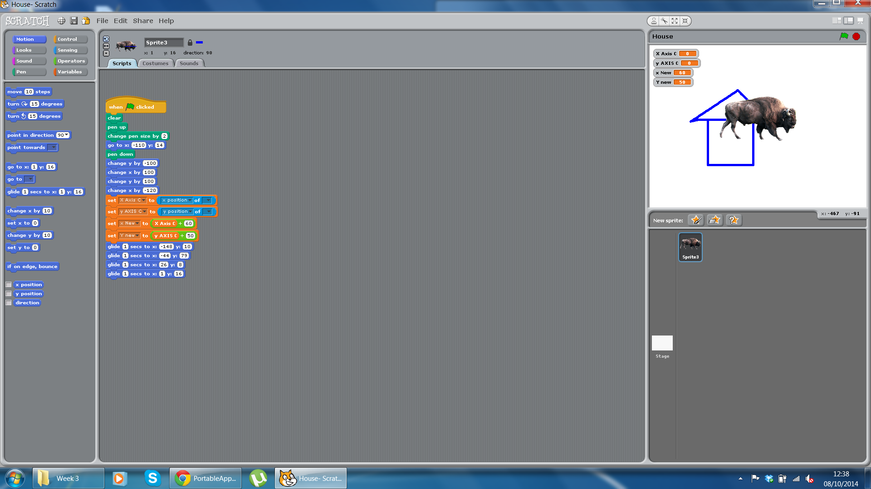

Sums



Maze Game

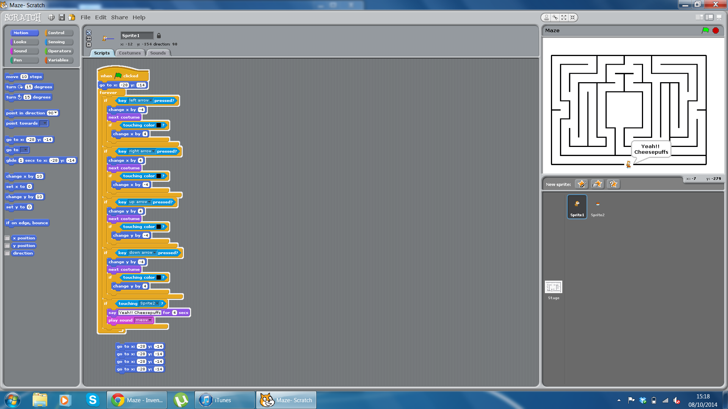

Problem 1

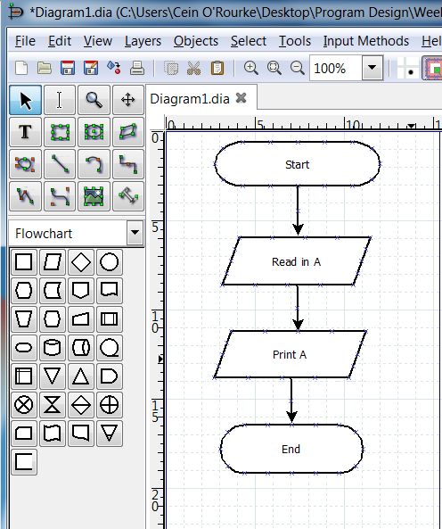

Problem 2

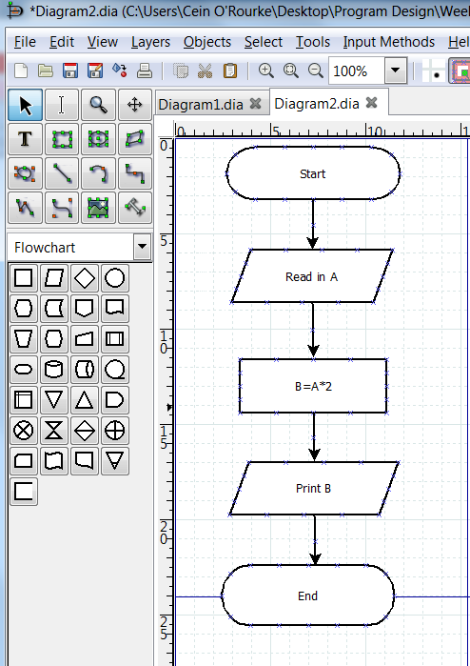

Problem 3

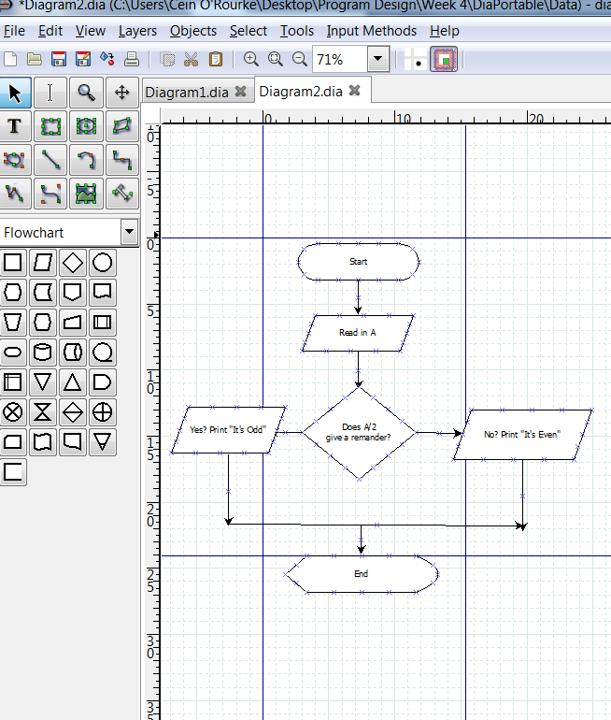

Problem 4

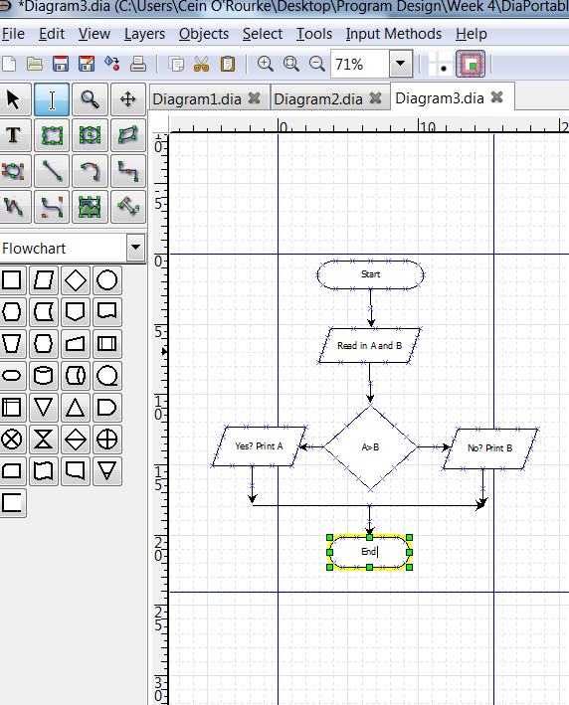

Problem 5

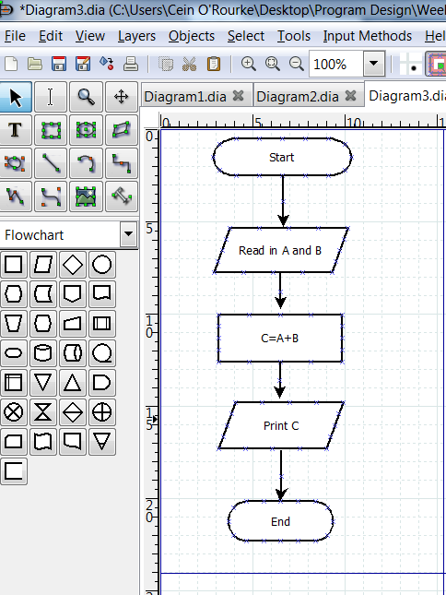

Problem 6

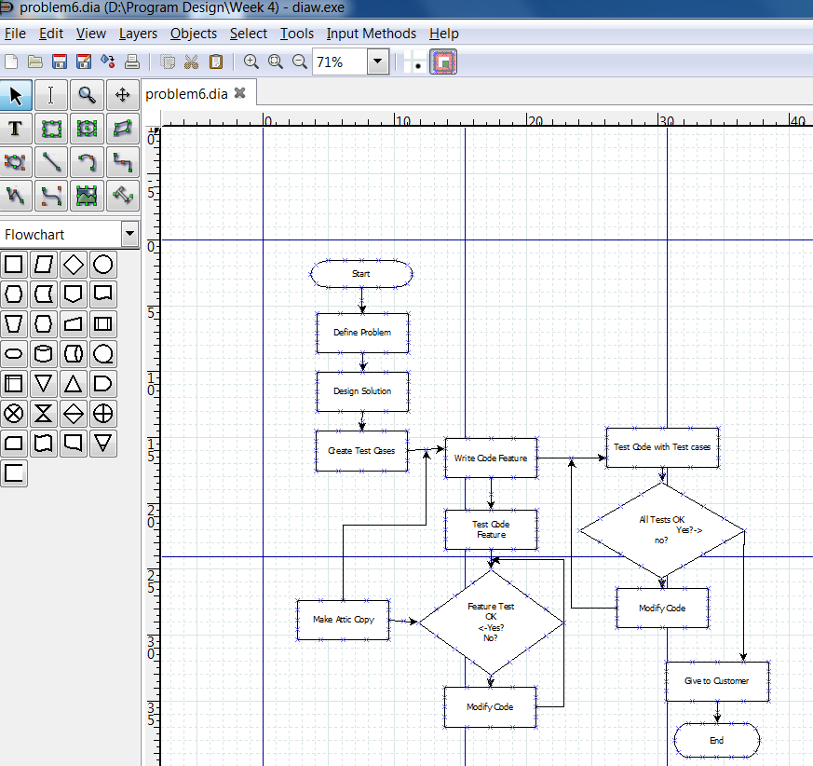

Problem 7

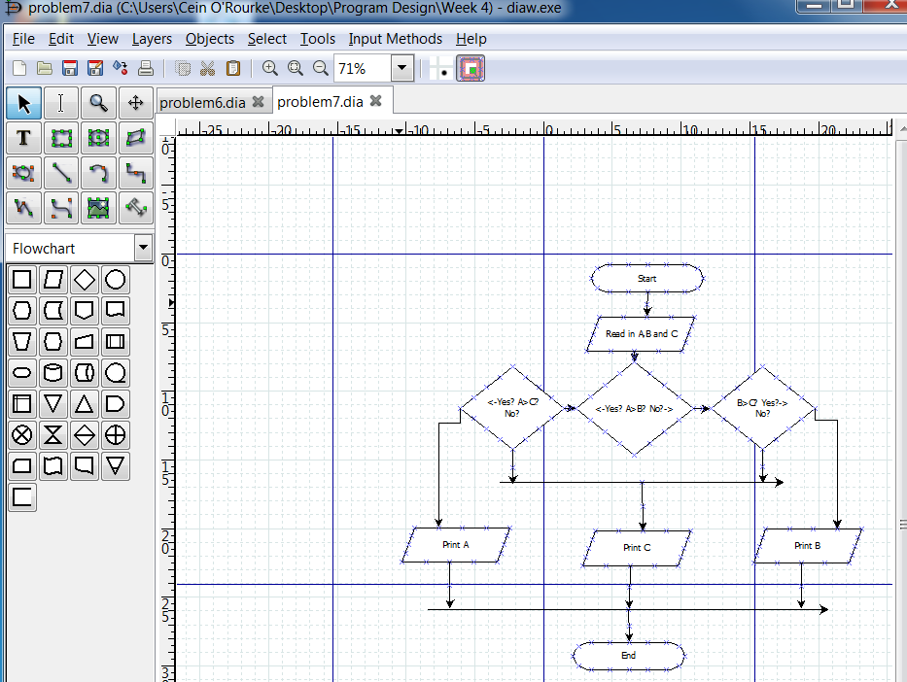

Problem 8

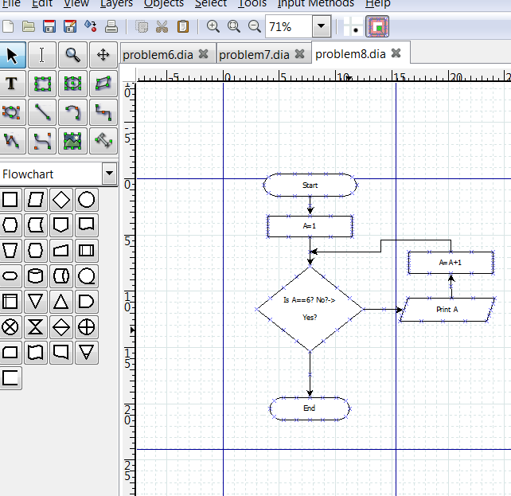

Problem 9

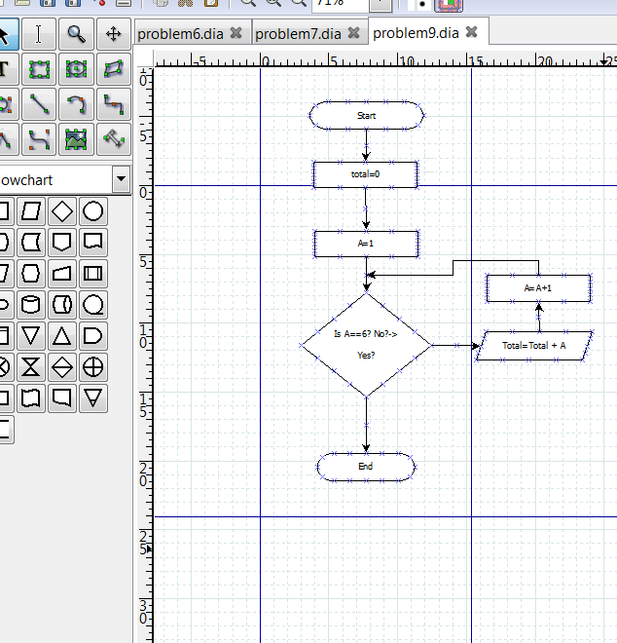

Problem 10

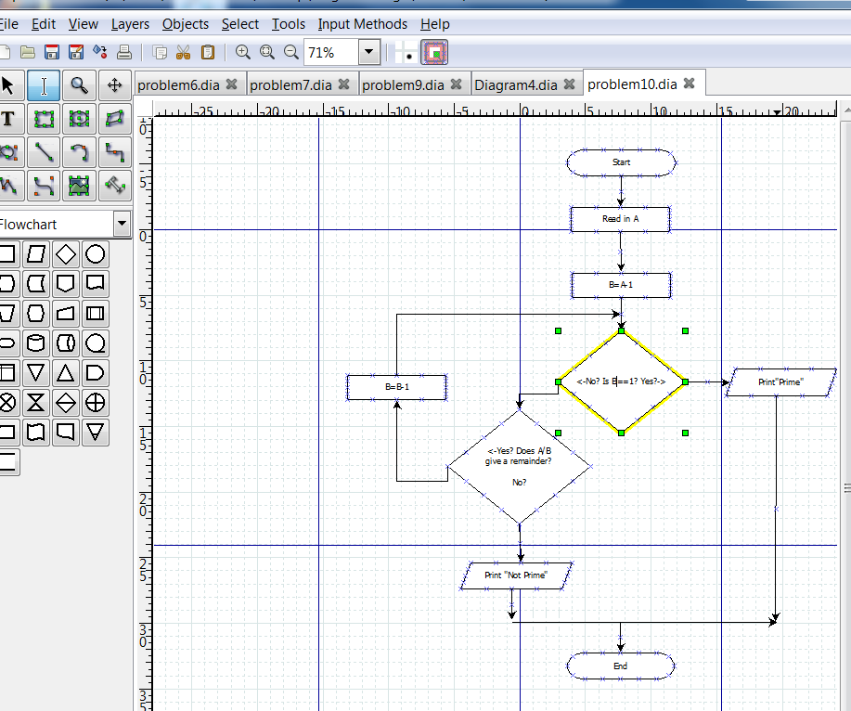

Exercise 4

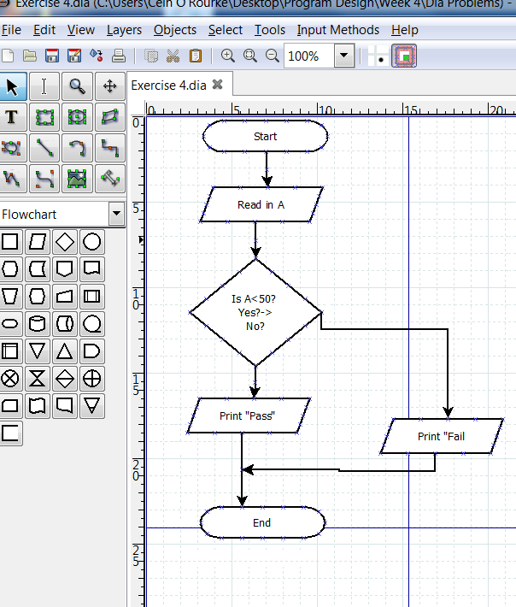

Problem 14

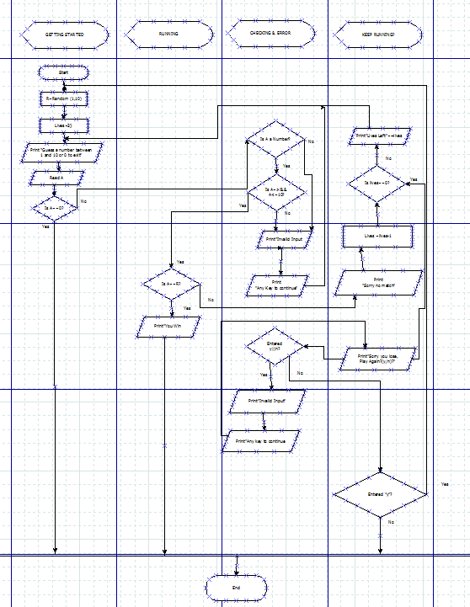

Problem 15

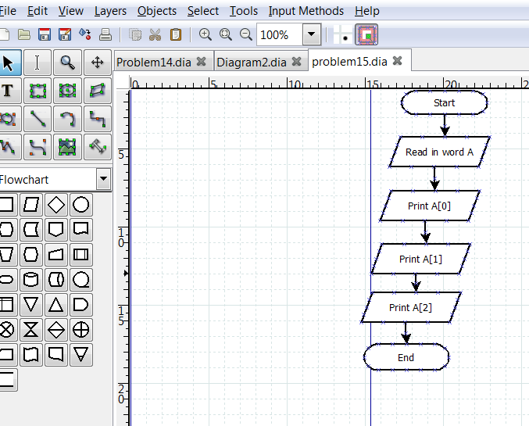

Problem 16

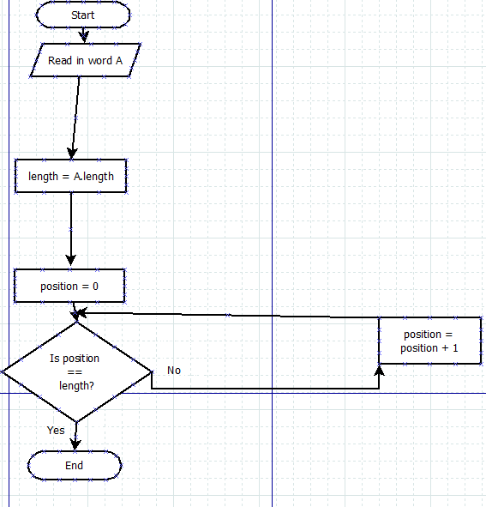

Problem 17

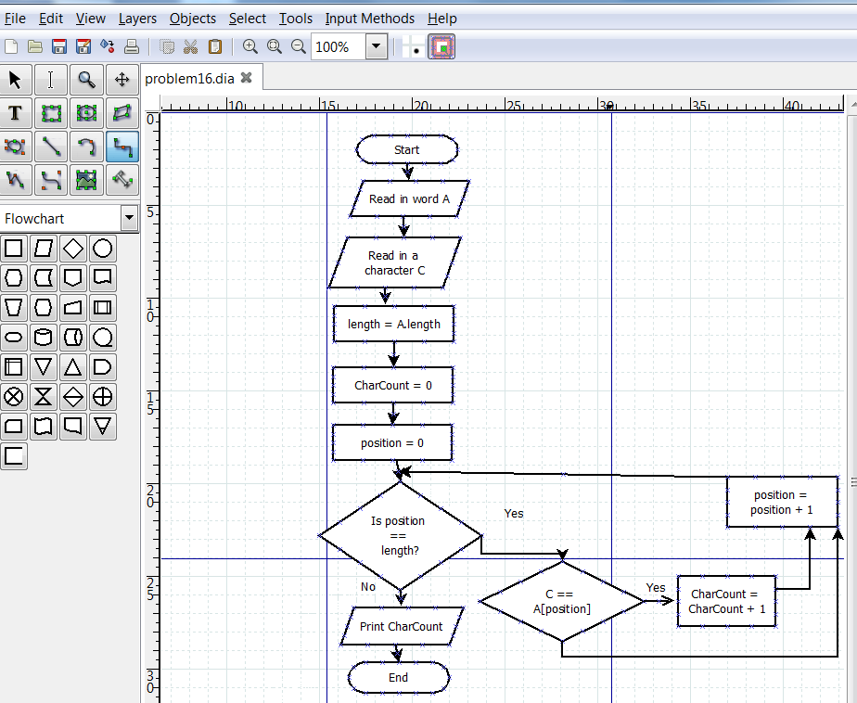

Problem 18

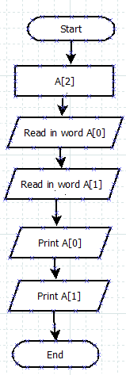

Problem 19

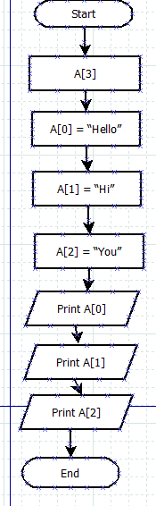

Problem 20

